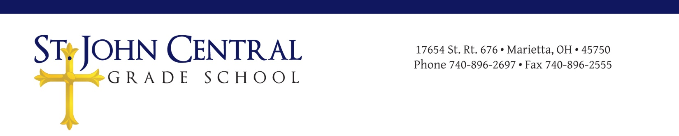
St. John Central School Title I Compact

What is Title I? Title I is a federal program with a purpose to ensure that all children have the opportunity to obtain a high-quality education by providing additional reading services. In order to ensure that all children have this opportunity, supplemental funding is provided to schools with a designated percentage of students who might qualify for a free and reduced lunch program in the public schools.

All members of the St. John Central School community play a role in a Title I program.

As TEACHERS, you will be responsible in the following ways:
- To provide curricular instruction that enables students to meet the required standards
- To foster communication by providing any assistance and/or information to parents as needed.
- To track and report student progress.
- To engage students in academic learning with enjoyable activities.

As a PARENT/GUARDIAN, you are expected to provide support in the following ways:
- To listen to your child read each day, and let them see you read.
- To be aware of what your child is learning and to interact accordingly
- To communicate with teachers periodically and to attend parent-teacher conferences, etc..
- To make sure your child attends school regularly.
- To help your child check and/or review homework assignments.

As a STUDENT, you are expected to do the following:
- To attend school regularly.
- To arrive prepared and ready to learn.
- To provide good effort in all assignments and to exhibit good behavior.
- To respect yourself and others.

As a PRINCIPAL, I/you am/are expected to support the Title I program in the following ways:
- To provide an environment that allows for positive communication between teachers, parents, and students.
- To require teachers to provide research-based instruction that supports student learning.
- To evaluate the Title I program to determine strengths, weaknesses, and compliancy.

Maria Huffman
Title I Teacher

Larry Moegling
Principal

